Python

PYTHON FEATURES

Python is a clear and powerful object-oriented programming language, comparable to Perl, Ruby, Scheme, or Java.
Some of Python's notable features:
- Uses an elegant syntax, making the programs you write easier to read.
- Is an easy-to-use language that makes it simple to get your program working. This makes Python ideal for prototype development and other ad-hoc programming tasks, without compromising maintainability.
- Comes with a large standard library that supports many common programming tasks such as connecting to web servers, searching text with regular expressions, reading and modifying files.
- Python's interactive mode makes it easy to test short snippets of code. There's also a bundled development environment called IDLE.
- Is easily extended by adding new modules implemented in a compiled language such as C or C++.
- Can also be embedded into an application to provide a programmable interface.
- Runs anywhere, including Mac OS X, Windows, Linux, and Unix, with unofficial builds also available for Android and iOS.
- Is free software in two senses. It doesn't cost anything to download or use Python, or to include it in your application. Python can also be freely modified and re-distributed because while the language is copyrighted it's available under an open-source license.
Some programming-language features of Python are:
- A variety of basic data types are available: numbers (floating point, complex, and unlimited-length long integers), strings (both ASCII and Unicode), lists, and dictionaries.
- Python supports object-oriented programming with classes and multiple inheritances.
- Code can be grouped into modules and packages.
- The language supports raising and catching exceptions, resulting in cleaner error handling.
- Data types are strongly and dynamically typed. Mixing incompatible types (e.g. attempting to add a string and a number) causes an exception to be raised, so errors are caught sooner.
- Python contains advanced programming features such as generators and list comprehensions.
- Python's automatic memory management frees you from having to manually allocate and free memory in your code.
See the SimplePrograms collection of short programs, gradually increasing in length, which shows off Python's syntax and readability.
Writing Pythonic code is not hard---but you have to get used to the (PEP) code style rules. You can test, check, and improve your code style at online resources such as Pythonchecker.com.

IDENTIFIERS
RESERVED WORDS
How You Run Programs

- The Interactive Prompt
- System Command Lines and File
  - To save programs permanently, you need to write your code in files, which are usually known as modules.
  - Modules are simply text files containing Python statements.
  - Once they are coded, you can ask the Python interpreter to execute the statements in such a file any number of times.
  - Python executes all the code in a module file from top to bottom each time you run the file.
- Unix-Style Executable Scripts: #!
- Clicking File Icons
  - [Desktop Entry]
  - Name=MyApp
  - Version=0.1
  - Exec=python3.8 /home/ayush/Python_programs/first_tkinter_program.py
  - Icon=/home/ayush/python-logo.png
  - Comment=hello world app print via GUI (tkinter)
  - Type=Application
  - Terminal=false
  - StartupNotify=true
  - Categories=GTK;GNOME
- Module Imports and Reloads

DATA TYPE:

- int
- float
- complex
- bool
- str
- bytes
- bytearray
- range
- list
- tuple
- set
- frozenset
- dict
- None
--------------------------------

PYTHON FUNDAMENTAL DATA TYPES:
#fundamental data type immutable
- int data type:
to hold integral values
whole numbers ==> 12, 345, 6789, ...
there are four way to specified valued in int data type:
  - Decimal form
(base = 10)
1 to 9
example:
>>> a = 129
>>> a
129
  - Binary form
base = 2
0 and 1
represent by 0b or 0B
example:
>>> a = 0B1111
>>> a
15
  - Octal form
base = 8
0 to 7
represent by 0o or 0O
example:
>>> a = 0o7777
>>> a
4095
  - Hexa form
base 16
0 to 9, a to f, A to F (we can use any case)
reprsent by 0x or 0X
example:
>>> a = 0xBeef
>>> a
48879

2. float data type:
a) Exponential form
example:
>>> f = 1.2e3
>>> f
1200.0
>>>

3. complex data type:
formate of complex number a+bj
a=Real part
b=Imaginary part
j=sequare root

4. bool data type:
True and False
example:
>>> a = True
>>> a
True
>>> True + True
2
>>> True + False
1
>>>

5. str data type:
single quotes ==> str
double quotes ==> string
triple quoes ==> multi line string literals

Index Operator:
positve index from rigth to left
negative index from left to right
example:
>>> s = 'Ayushsahu'
>>> s
'Ayushsahu'
>>> s[0]
'A'
>>> s[2]
'u'
>>> s[-1]
'u'
>>> s[-3]
'a'
>>>

Slice Operator:
string_name[begin:end]
returns substring from begin index to end-1 index
example:
>>>s = ‘Aysuhsahu’
>>> s[1:9]
'yushsahu'
>>> s[0:9]
'Ayushsahu'
>>> s[1:]
'yushsahu'
>>> s[0:10]
'Ayushsahu'
>>> s[0:5]
'Ayush'
>>> s[:9]
'Ayushsahu'
>>> s[-9:-4]
'Ayush'
>>> s[-4:-9]
“”
>>>

Jump Operator:
format: string_name[begin:end:step]

String Repetation Operator “ * “:

-----------------------------------

BASE CONVERSION:

bin()
oct()
hex()

--------------------------

TYPE CASTING OR TYPE CONVERSION:

- int()
- float()
- complex()
- bool()
- str()

int():
int(12.323) ==> 12 #float to int
int(True) ==> 1 #bool to int
int(“10”) ==> 10 #str to int **string value must be base 10
int(10+20j) ==> TypeError #complex to int not possible

float():
float(10) == >10.0 #int to float
float(10+20j) ==> TypeError #complex to float not possible
float(True) ==> 1.0 #bool to float
float(“10”) ==> 10.0 #str to float **string value must be base 10

complex():
other type to complex type

FORM-1: complex(x) ==> x+0j
FROM-2: complex(x,y) ==> x+yj

FORM-1: complex(x) ==> x+0j:-
example:
>>> complex(10)
(10+0j)
>>> complex(10.2)
(10.2+0j)
>>> complex(True)
(1+0j)
>>> complex("10")
(10+0j)
>>> complex("ten")
Traceback (most recent call last):
File "<pyshell#23>", line 1, in <module>
complex("ten")
ValueError: complex() arg is a malformed string
>>>
FROM-2: complex(x,y) ==> x+yj:-
example
>>> complex(10,20)
(10+20j)
>>> complex(True,False)
(1+0j)
>>> complex("10","20")
Traceback (most recent call last):
File "<pyshell#26>", line 1, in <module>
complex("10","20")
TypeError: complex() can't take second arg if first is a string
>>>

bool():

for int argument
example:
bool(0) ==> False
bool(10) ==> True #none zero value is True
bool(-10) ==> True

for float argument
example:
bool(0.0) ==> Flase
bool(0.1) ==> True

for complex number
both real and imaginar part are zero then False otherwise True

for str argument
argument is emoty string ==> ‘’ ==> then only result is False
example:
>>> bool('')
False
>>>

str():
any type can pass

---------------------------

OBJECT:
#all fundamental data types are immutable

reference
#object create

#x=10

10
x

reference
object

#create new object of 10 with different refernce
z
#z=10
reference
#but reference z, points to existed object of 10
#object all fundamental object are immutable
#so memory utilization performance
#immutablility required because if one person change the content then all the remaining reference will be affected.

RESUABLE OF SAME OBJECT SUCH CONCEPT DEPEND ONLYIN THE FOLLOWING RANGES:

int ==> 0 to 256
bool ==> always
str ==> always
float ==> resuability concept is not applicable to float, By default float always create new object.
complex ==> resuability concept is not applicable to complex, By default complex always create new object.

#at the time pythn interpreter starts:
form 0 to 256 integer object will be created at begininng.

-----------------------------

#bytes data type and bytearray data type is used to represent binary data like image, video files and audio files.

6. bytes data type:

it represent a group of byte numbers just like array
bytes_variable_name =bytes(variable_name)
a. in bytes data type the value must be in the range 0 to 256
b. immutable

Example:
>>> x = [10,20,30,40]
>>> b=bytes(x)
>>> type(b)
<class 'bytes'>
>>> b
b'\n\x14\x1e('
>>> b[0]
10
>>> b[-1]
40
>>> b[0:3]
b'\n\x14\x1e'
>>> for val in b: print(val)

10
20
30
40
>>> x =[10,20,256,258]
>>> b = bytes(x)
Traceback (most recent call last):
File "<pyshell#10>", line 1, in <module>
b = bytes(x)
ValueError: bytes must be in range(0, 256)
>>> x = [10,20,30,40]
>>> b = bytes(x)
>>> b[0]
10
>>> b[0] = 120
Traceback (most recent call last):
File "<pyshell#14>", line 1, in <module>
b[0] = 120
TypeError: 'bytes' object does not support item assignment
>>>

7. bytearray data type:

a) bytes and bytearray both are same.
b) but bytearry is mutable
example:
>>> b = [10,20,30,40]
>>> x = bytearray(b)
>>> type(x)
<class 'bytearray'>
>>> x[0] = 120
>>> for val in x: print(val)

120
20
30
40
>>>

8. list data type:

insertion order is preserved
duplicates are allowed
hetergeneous object (value) is allowed
growable
degradable
index operator allowed
slice operator allowed
String Repetation Operator
list is represent by square braces convension
list_name = [] ==> Empty list
list(sequence) ==> list function is also available

example:
>>> list_name = []
>>> type(list_name)
<class 'list'>
>>> list_name.append(10)
>>> list_name.append(20)
>>> list_name.append(30)
>>> list_name.append(40)
>>> list_name
[10, 20, 30, 40]
>>> list_name.append(10)
>>> list_name
[10, 20, 30, 40, 10]
>>> list_name.append('ayush')
>>> list_name
[10, 20, 30, 40, 10, 'ayush']
>>> list2 = list_name*2
>>> list2
[10, 20, 30, 40, 10, 'ayush', 10, 20, 30, 40, 10, 'ayush']
>>> list_name.remove(20)
>>> list_name
[10, 30, 40, 10, 'ayush']
>>>
>>> l = [1,2,3,4,-1]
>>> l[0:-1]
[1, 2, 3, 4]
>>> l[1:-1]
[2, 3, 4]

#Difference between list and tuple is list are mutable and tuple are immutable.

9. tuple data type:

list and tuple are same
but tuple is immutable
not growable
not degradable
tuple represent by parentheses convension
tuple_name = () ==> empty tuple
one_element_tuple = (one_element,) #in single element tuple comma is compulsery example:
>>> t = (10,)
>>> type(t)
<class 'tuple'>
>>>
**Note that it is actually the comma which makes a tuple, not the parentheses.
**The parentheses are optional, except in the empty tuple case
example:
>>> t = 10,20,3040,
>>> type(t)
<class 'tuple'>
>>>

example:
>>> tuple_name = (10,'ayush', True, 10)
>>> type(tuple_name)
<class 'tuple'>
>>> tuple_name
(10, 'ayush', True, 10)
>>> t2 = tuple_name*2
>>> t2
(10, 'ayush', True, 10, 10, 'ayush', True, 10)
>>>

#tuple is immutable so we cannot assigne value. So if you need to changing value in a tuple

t = ('275', '54000', '0.0', '5000.0', '0.0')
lst = list(t)
lst[0] = '300'
t = tuple(lst)

10. range data type:

range data type represent a sequence of value
immutable
only integre value
#range is data type as well as function
index operator allowed
slice operator allowed
represent by
FROM-1: range(end) ==> it represents value from 0 to end-1

example:
>>> r = range(10)
>>> type(r)
<class 'range'>
>>> r
range(0, 10)
>>> for val in r: print(val)

0
1
2
3
4
5
6
7
8
9
>>>

FROM-2: range(start,end) ==> it repersent numbers from start to end-1

FROM-3: range(start,end,step)

#Difference between list and set:
#list insertion order preserved and duplicate object
#set insertion order not preserved

11. set data type:

insertion order not preserved
duplicate is not allowed
heterogeneous object allowed
mutable
growable
degradable
index operation is not applicable due to order is on preserved
slice operation is not applicable due to order is on preserved
represent by curle braces convension
empty set is cerated as: set_name = set()
set() function is alsoavailable

example:
>>> s = {10,20,30,10,20,30}
>>> type(s)
<class 'set'>
>>> s
{10, 20, 30}
>>> s.add('ayush')
>>> s
{'ayush', 10, 20, 30}
>>> s.remove(20)
>>> s
{'ayush', 10, 30}
>>>

12. frozenset data type:

frozenset same as set data type
but frozenset is immutable
frozenset represent by frozenset_name = frozenset(value)

example:
>>> fs = frozenset(s)
>>> type(fs)
<class 'frozenset'>
>>> fs
frozenset({10, 20, 30})
>>> fs.add(50)
Traceback (most recent call last):
File "<pyshell#12>", line 1, in <module>
fs.add(50)
AttributeError: 'frozenset' object has no attribute 'add'
>>>
#byte, bytearray, range, list, tuple, set, frozenset ==> groups of individual objects.

13. dict data type:

dictionary
words ==> meaning
key --> value
insertion order not preserve
mutable
growable
decradable
index and slice is not applicable
dict represent groups of key-value pairs
duplicates key are not allowed
duplicate value are allowed
key can be any type of object
value can be any type of object
heterogeneous allowed
represent curle braces convension
when we take only just open and close curle braces by defalut it treated as empty dictionary. Means empty dictionary created as dictionary_name = {}
#if we trying to add duplicate key then old value is replace with new value.
To add key and value in dictionary ==> d[key]=value

Example:
>>> d = {28:'ayush', 16: 'muskan', 3: 'gujan'}
>>> type(d)
<class 'dict'>
>>> d
{28: 'ayush', 16: 'muskan', 3: 'gujan'}
>>> d = {}
>>> type(d)
<class 'dict'>
>>> d[100] = 'prerna'
>>> d[23] = 'pulkit'
>>> d
{100: 'prerna', 23: 'pulkit'}
>>> d[23] = 'prayank'
>>> d
{100: 'prerna', 23: 'prayank'}
>>>

14. None data type:

None means no value is associate

example:
>>> def f1():
a=10

>>> def f2(): print("Hello Don't be like None")
f1() function going to return something and we are trying to ptint that value.

>>> print(f1())
None
>>> print(f2())
Hello Don't be like None
None
>>>

-------------

PASS KEYWORD:

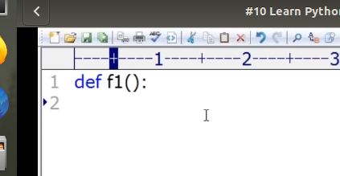

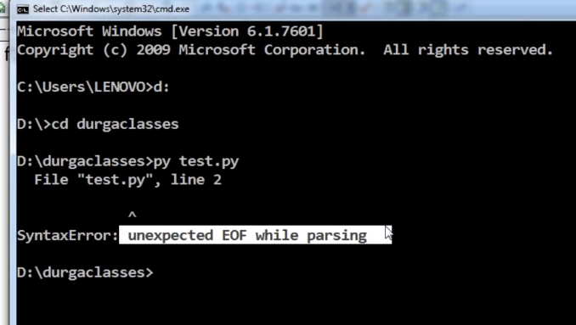

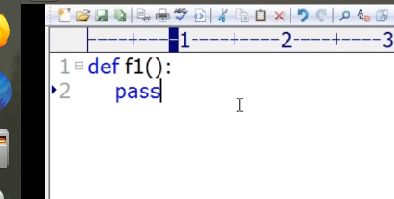

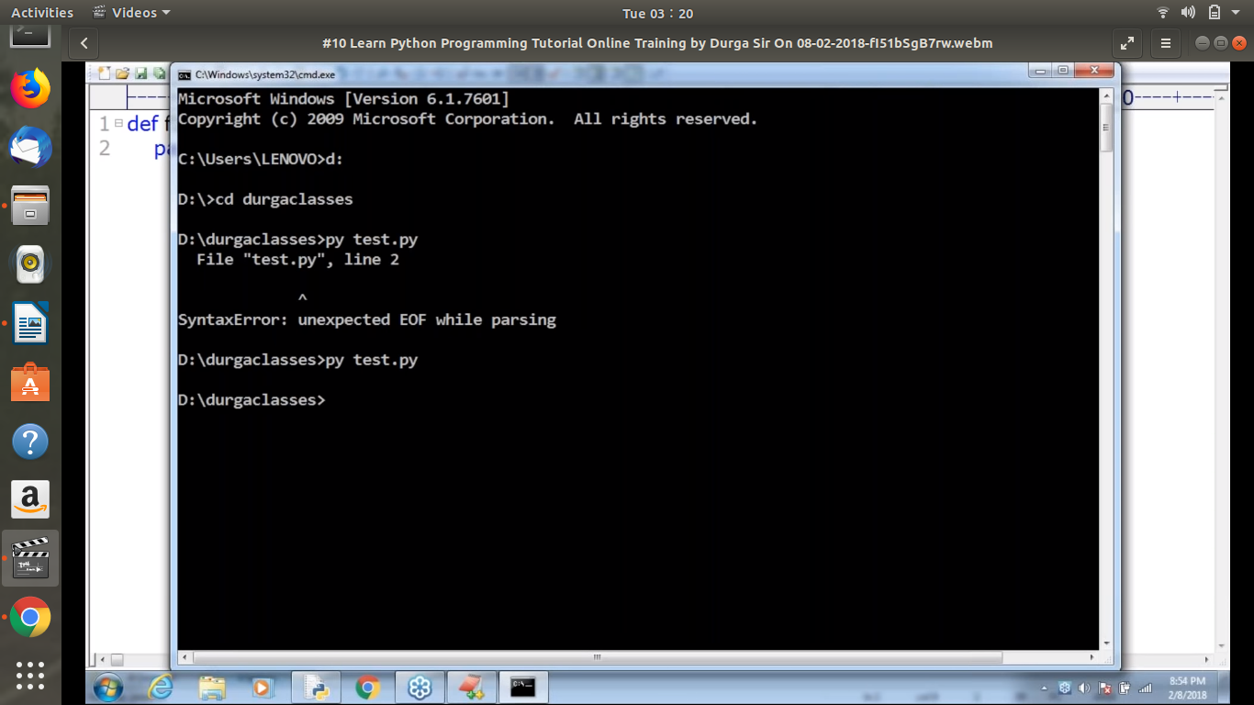

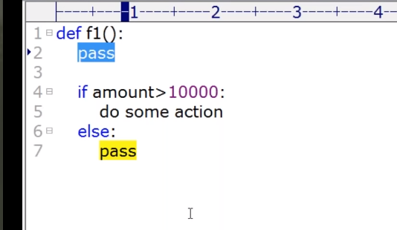

-----------------------

CONSTANTS:
in python there is no termenology is to fixed or constant value.
If you want value is not change then value define in upper case:
example:
MAX_VALUE=10

-------------------------------

Escape Sequence | Meaning
\newline | Ignored
\\ | Backslash (\)
\' | Single quote (')
\" | Double quote (")
\a | ASCII Bell (BEL)
\b | ASCII Backspace (BS)
\f | ASCII Formfeed (FF)
\n | ASCII Linefeed (LF)
\r | ASCII Carriage Return (CR)
\t | ASCII Horizontal Tab (TAB)
\v | ASCII Vertical Tab (VT)
\ooo | ASCII character with octal value ooo
\xhh... | ASCII character with hex value hh...

OPERATORS:

- Arithmetic Operators
- Relational Operators or Comparison Operators
- Logical Operators
- Bitwise Operators
- Assignment Operators
- Special Operators

ARITHMETIC OPERATORS:

+ ==> Addition Operator
- ==> Subtraction Operator
* ==> Multiplication Operator
/ ==> Division Operator #it always result float value
% ==> Modulo Operator
// ===> Floor Division Operator #if both argument is integre then result int value or
#if any argument is float then resulte float value
** ==> Exponent Operator or Power Operator

+ Operator applicable for str type also ==> string concatenation Operator
#bhot argument must be string

* Operator applicable for str type ==> string multiplication operator
#first argument must be string and second argument must be int value only.
#order is not important

RELATIONAL OPERATORS:

> ==> greater
>= ==> greater than equale to
< ==> lesser
<= ==> lesser than equale to

exampl-1: relational operation on int
a = 10
b = 20
print(“a>b is”, a>b)#F
print(“a>=b is”, a>=b)#F
print(“a<b is”, a<b)#T
print(“a<=b is”, a<=b)#T

example-2: relational operation on str
#relational operation on string is perform base on alphabetical roder(consider unicode value)
a = ‘ayush’
b = ‘sahu’
print(“a>b is”, a>b)#F
print(“a>=b is”, a>=b)#F
print(“a<b is”, a<b)#T
print(“a<=b is”, a<=b)#T

exampl-3: relational operation on boolean
a = True
b = False
print(“a>b is”, a>b)#T
print(“a>=b is”, a>=b)#T
print(“a<b is”, a<b)#F
print(“a<=b is”, a<=b)#F

CHAINING OF RELATION OPERATION:

atleast one comparison is false then result is always false
if any comparison is True then result is always true

example:
>>> 10<20<30<40
True
>>> 10<20<30>40
False
>>>

EQUALITY OPERATORS (==, !-)
# these operator(equality) are content comparison operator

== ==> equality
!= ==> not equality

#content is same then return True else False

example:
>>> 10 != 20
True
>>> False == False
True
>>> 10 == True
False
>>> 'ayush' == 'ayush'
True
>>>

CHANING OF EQUALITY OPERATOR:

example:
>>> 10 == 20 == 30 == 40 == 50
False
>>> 10 == 5+5 == 3+7 == 2*5
True
>>> 'a' == 97
False
>>>

LOGICAL OPERATORS:

and ==> if both arguments are True then only True
or ==> if atleast one argument is True then True
not

For boolean:

if we apply logical operation on boolean then result will be in boolean
example:
True and False ==> False
True or False ==> True
not True ==> False

For non-boolean types:

0 means False
non-zero means True
empty string treated as False

x and y:
if x evaluates to false then result is x otherwise return y
example: 10 and 20 == > 20
0 and 20 ==> 0

x or y:
if x is evaluates to True then returns x otherwisereturn y
example:
10 or 20 ==> 10
0 or 20 ==> 20
0 or 0 ==> 0

not x:

example:
not 10 ==> False
not ‘’ ==> True
not 0 ==> True

BITWISE OPERATORS:

#bitwise operator is applicable only for int and boolean.
& ==> if both bits are 1 then only 1 otherwise 0
| ==> if atleast one bit is 1 then 1 otherwise 0
^ ==> x-or ==> if both bits are different then 1 otherwise 0
~ ==> bitewise complement operator
<< ==> bitwise left shift
>> ==> bitwise right shift

4&5 ==> valid
Unsopported type for bitwise operator
True & True ==> valid
10.5 & 6.2 ==> not valid

LEFT SHIFT OPERATOR:
#Right hand sidevacant cells fill with 0s
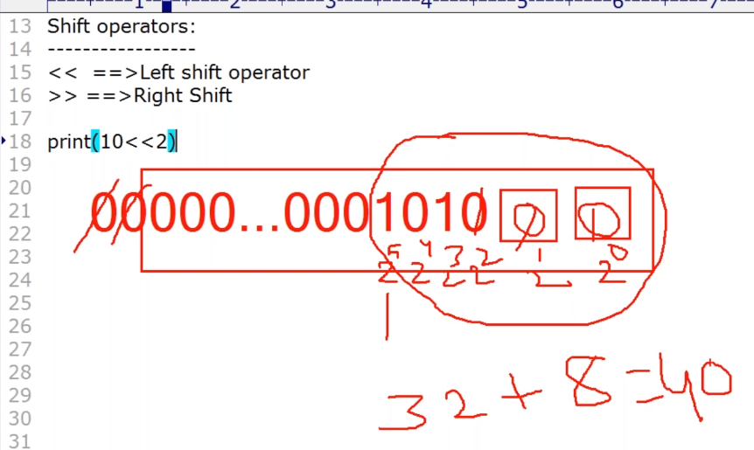

RIGHT SHIFT OPERATOR:
#Left hand side vacant cells fill with sign bit
+ve numbers ==> 0
-ve number ==> 1
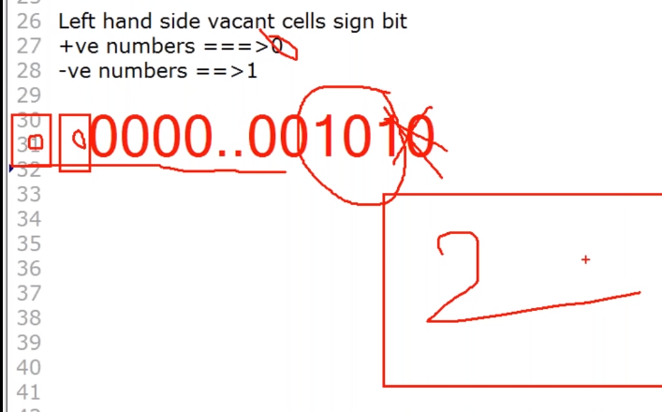

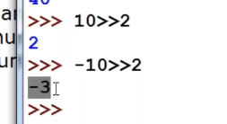

ASSIGNMENT OPERATORS:

example:
x = 10
a,b,c,d = 10,20,30,40

COMPOUND ASSIGNMENT OPERATOR:

+=
-=
*=
/=
5=
//=
**=
&=
|=
^=
<<=
>>=

TERNARY OPERATOR:

x=firstValue if condition else secondValue

x=firstValue if condition1 else secondValue if condition2 else thirdValue

input():
whaterver data reading from keyboard it is in form of string

SPECIAL OPERATOR:
a
1. IDENTITY OPERATOR
2. MEMBERSHIP OPERATOR

10
b
IDENTITY OPERATOR:

a. is operator
b. not is operator
#is operator also used to compare address(reference)

a = 10
b = 10

#who we check a and b point to same object? Then use is operator

example:
>>> a = 10
>>> b = 10
>>> print(a is b)
True
>>>

MEMBERSHIP OPERATOR:

a. in operator
b. not in operator

example:
>>> list1 = [10,20,30]
>>> print(10 in list1)
True
>>> print(70 in list1)
False
>>>

>>> s = 'hello Learing Python is easy'
>>> print('hello' in s)
True
>>> print('L' in s)
True
>>> print('p' in s)
False
>>> print(' ' in s)
True
>>>

OPERATOR PRECEDENCE:

Import
from module_name import module_function
alesing ==> as

INPUT AND OUTPUT STATEMENTS:
Read dynamic data from the keyboard

python-2
raw_input() ==> str
we requiredto use typecasting functions

input()
not consider as str type what every type provided
we are not required typecassting
Python-3
input()
in python3 input() function is similar as raw_input() function

How tp read multiple values from the keyboard in a single line:
a,b=[int(x) for x in input(“Enter two numbers:”).split()]

Read 3 float values from the keyboard which are specified with , seperatoion and print sum
a,b,c=[int(x) for x in input(“Enter 3 float values:”).split(‘,’)]

eval():
#evaluate corrosponding data
x=eval(“10+20+30”)
print(x)#60

Read 3 different values from the keyboard which are specified with , seperatoion and print theri type
a,b,c=[eval(x) for x in input(“Enter 3 values:”).split(‘,’)]

command line argument
argv ==> list type
from sys import argv
print(type(argv))
print(argv)

output print
print()
var-arg
sep=’’
end=’’
formatted string

print(“formatted string” %())
Form-1:
print() without any arguments
From-2:
print(string)
+ ==> both arguments should be str type only
* ==> one argument should be str and other should be int

print(‘ayush’+’sahu’) ==> ayushsahu
print(‘ayush’,’sahu’) ==> ayush sahu

Form-3:
print() with variable number of arguments:

var-arg
sep=”” ==> sep attributs
print() with end attribute:
print(object)

print(formatted string):
%i ==> int type
%d ==> int type
%f ==> float type
%s ==> str type
print(‘formatted string’ %(variable list))

print() function with replacement operator:
{} ==> replacement operator

Python print() Function

The print() function prints the specified message to the screen, or other standard output device.
The message can be a string, or any other object, the object will be converted into a string before written to the screen.

Syntax
print(object(s), separator=separator, end=end, file=file, flush=flush)

Parameter Values
Parameter | Description
object(s) | Any object, and as many as you like. Will be converted to string before printed
sep='separator' | Optional. Specify how to separate the objects, if there is more than one. Default is ' '
end='end' | Optional. Specify what to print at the end. Default is '\n' (line feed)
file | Optional. An object with a write method. Default is sys.stdout
flush | Optional. A Boolean, specifying if the output is flushed (True) or buffered (False). Default is False

More Examples

Example
Print more than one object:
print("Hello", "how are you?")
Run example »

Example
Print a tuple:
x = ("apple", "banana", "cherry")
print(x)
Run example »

Example
Print two messages, and specify the separator:
print("Hello", "how are you?", sep="---")
Run example »
❮ Built-in Functions

FLOW CONTRONL;
#3 type of flow control:
1. Conditinal statements/selection statements:
if
if-else
if-elif-else

2.Iterative statements:
loops

for loop
#if we know numbers of iteration in advance then go with for loop
while loop
#if we don’t know numbers of iteration in advance thengo with while loop
#iteration terminate when condition is false

3. Transfer statements:
break
#Based on some condition if we want to break loop execution.

For-else
while-else
try-except-else-finally

#else part is execute in loop, when break is not exucte.
#else means loop without break
example:
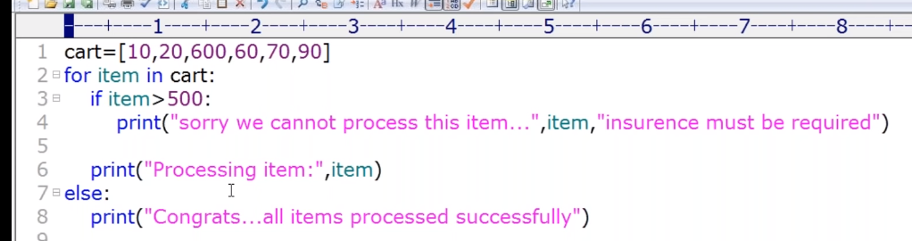

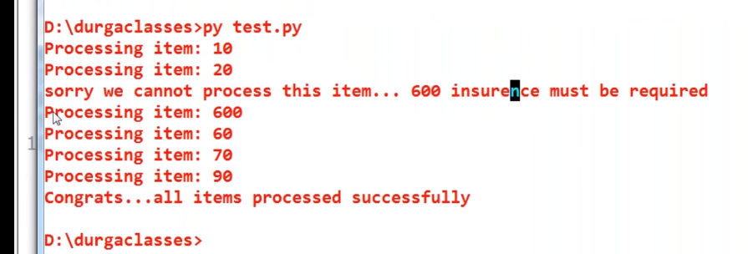

contiune
#skip current iteration and cntinue for the next iteration.
#while condition:
#body
#body
#body
#continue
#body
pass
#pass is keyword in python
#it is an empty statement
#it is null statement
#it won’t do anything

example:
if True: pass
else:
print(“hello”)

example:
def f1():
print(“hello”)

def f2():
pass
If you want to define such type of empty block

f1()
f2()

del:
del is a keyword in python
i don’t want reference variable as well as corrosponding object then use del keyword
example:
>>> x = 10
>>> print(x)
10
>>> del(x)
>>> print(x)
Traceback (most recent call last):
File "<pyshell#3>", line 1, in <module>
print(x)
NameError: name 'x' is not defined
>>>

None:
if you want reference variable but not corrosponding object then use None
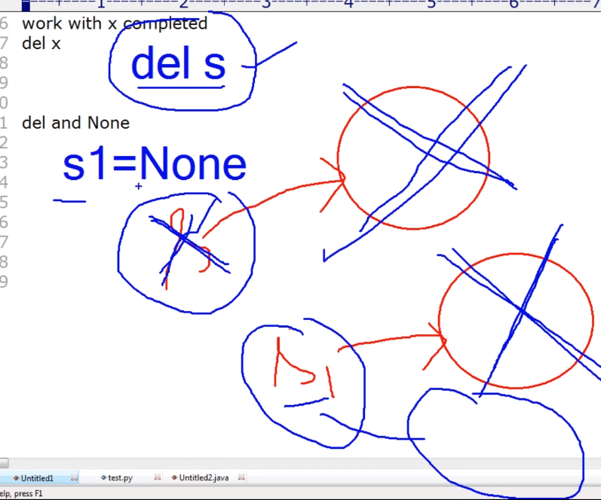
example:
>>y=None
>>print(y)
>>None

str DATA STRUCTURE:
single quotes ==> str
double quotes ==> string
triple quoes ==> multi line string literalt

How to access characters from string:
1. By using indexing
2. By using slice operator

1. By using Index Operator:
positve index from rigth to left(forward direction)
negative index from left to right(backward direction)
#if we try to access string if index is not there so we got error out of index

example:
>>> s = '123456789'
>>> s[0:7:1]
'1234567'
>>> s[0:7:2]
'1357'
>>> s[0:7]
'1234567'
>>> s[0:]
'123456789'
>>> s[:]
'123456789'
>>> s[::]
'123456789'

2. By using slice operator:
sting_name[beginindex:endindex:step]

from begin index to end-1 index and everytime increment by 1 (or step)

RULES:
*step value can be either +ve or -ve
*if step value +ve then it should be forward direction(Left to Right)
*if step value -ve then it should be forward direction(Right to Left)

*if +ve forward direction from begin to end-1
*if -ve backword direction from begin to end+1

#if step value is +ve ==> move forword direction ==> from begin to end-1 index
#if step value is -ve ==> move backword direction ==> from begin to end+1 index

RULE

In forward direction:
default value for begin: 0
default value for end: lengthof the string
default value for step: 1

In backword direction:
default value for begin: -1
default value for end: -(lengthof the string+1)
default value for step: 1

example:
>>> s = '123456789'
>>> s[2:8:-1]
''
>>> s[2:8:0]
Traceback (most recent call last):
File "<pyshell#9>", line 1, in <module>
s[2:8:0]
ValueError: slice step cannot be zero
>>> s[-1:-6:-1]
'98765'
>>> s[-1:-6]
''
>>> s[2:-5:1]
'34'

TO REMOVE SPACE:

lstrip() ==> beginning spacce remove
rstrip() ==> end space remove
strip() ==> begin and end space remove

COUNTING SIBSTRING IN THE GIVEN STRING:
s.count(substring)
s.count(substring,begin,end)
from begin index to end-1 index substring

REPLACING A STRING WITH ANOTHER STRING:
s.replace(oldstring,newstring)

SPLITTING OF STRINGS:
s.split(seperator)

JOIN() FUNCTION:
join function syntax: variable_name = ‘specifie-seperator’.join(paramater)
example:
list_name = [‘Ayush’,’Sahu’]
s = ‘-’.join(list_name)
print(list_name)#Ayush-Sahu

CHAMGING CASE OF A STRING:
upper()
lower()
swapcase()
title() ==> Python Is Easy To Learn
capitalize() ==> Python is easy to learn
casefold()

CHECKING STARTING AND ENDING PART OF THE STRING:
s.startswith(‘starting_word_of_string’)
s.endswith(‘end_word _of_sting’)

difference between function and class:

#the function decalred outside a class is called function.
#the function decalred inside a class is called method.

Example:
def f1():
print(‘Hello this is function’)
class Student:
def info(self):
print(‘It is method and don’t fget confuse’)

f1()
s=Student()
s.info()

LIST DATA STRUCTURE:

insertion order is preserved
duplicates are allowed
hetergeneous object (value) is allowed
growable
degradable
index operator allowed
slice operator allowed
String Repetation Operator
list is represent by square braces convension
list_name = [] ==> Empty list
list(sequence) ==> list function is also available
list_name.split(seperator)
Nested Lists ==> eample: [10,20,[30,40]]
concatenation operation ==> both should be list objects

Comparing List object:
1. The number of elements must be equal
2. The order should be same
3. The contents should be same(including case)

List Comprehension:
list_variable = [ expression for x in sequence]
list_variable = [ expression for x in sequence if condition]

IMPORTANT FUNCTION AND METHOD OF LIST:

Python List append() | Add Single Element to The List
Python List extend() | Add Elements of a List to Another List
Python List insert() | Inserts Element to The List
Python List remove() | Removes Element from the List
Python List index() | returns smallest index of element in list
Python List count() | returns occurrences of element in a list
Python List pop() | Removes Element at Given Index
Python List reverse() | Reverses a List
Python List sort() | sorts elements of a list
Python List copy() | Returns Shallow Copy of a List
Python List clear() | Removes all Items from the List
Python any() | Checks if any Element of an Iterable is True
Python all() | returns true when all elements in iterable is true
Python ascii() | Returns String Containing Printable Representation
Python bool() | Converts a Value to Boolean
Python enumerate() | Returns an Enumerate Object
Python filter() | constructs iterator from elements which are true
Python iter() | returns iterator for an object
Python list() Function | creates list in Python
Python len() | Returns Length of an Object
Python max() | returns largest element
Python min() | returns smallest element
Python map() | Applies Function and Returns a List
Python reversed() | returns reversed iterator of a sequence
Python slice() | creates a slice object specified by range()
Python sorted() | returns sorted list from a given iterable
Python sum() | Add items of an Iterable
Python zip() | Returns an Iterator of Tuples
TUPLE DATA STRUCTURE:

list and tuple are same
but tuple is immutable
not growable
not degradable
tuple represent by parentheses convension
tuple_name = () ==> empty tuple
one_element_tuple = (one_element,) #in single element tuple comma is compulsery
example:
>>> t = (10,)
>>> type(t)
<class 'tuple'>
>>>
**Note that it is actually the comma which makes a tuple, not the parentheses.
**The parentheses are optional, except in the empty tuple case
example:
>>> t = 10,20,3040,
>>> type(t)
<class 'tuple'>
>>>

tuple(sequence) function is also available
indexing
slice operator
concatination operator
repetiton operator

FUNCTION AND METHODOF TUPLE
Method | Description
Python Tuple count() | returns occurrences of element in a tuple
Python Tuple index() | returns smallest index of element in tuple
Python any() | Checks if any Element of an Iterable is True
Python all() | returns true when all elements in iterable is true
Python ascii() | Returns String Containing Printable Representation
Python bool() | Converts a Value to Boolean
Python enumerate() | Returns an Enumerate Object
Python filter() | constructs iterator from elements which are true
Python iter() | returns iterator for an object
Python len() | Returns Length of an Object
Python max() | returns largest element
Python min() | returns smallest element
Python map() | Applies Function and Returns a List
Python reversed() | returns reversed iterator of a sequence
Python slice() | creates a slice object specified by range()
Python sorted() | returns sorted list from a given iterable
Python sum() | Add items of an Iterable
Python tuple() Function | Creates a Tuple
Python zip() | Returns an Iterator of Tuples
sorted(t,reverse=True) sort in reverse order

TUPLE PACKING AND UNPACKING:

Tuple Packing means grouping into single
Example:
This is tuple packing.

a = 10
b = 20
c = 30
d = 40
t = a,b,c,d
print(t) #(10,20,30,40)

Tuple Unpacking

Example:
Tuple unpacking.
t = (10,20,30,40)
a,b,c,d = t
print(‘a=’a,’b=’b,’c=’c,’d=’d) #a=10 b=20 c=30 d=40

**PACKING AND UNPACKING CONCEPT IS APPLICABLEAT ANY TYPE OF SEQUENCE(tuple, list, set, string)

SET DATA STRUCTURE:

insertion order not preserved
duplicate is not allowed
heterogeneous object allowed
mutable
growable
degradable
index operation is not applicable due to order is on preserved
slice operation is not applicable due to order is on preserved
represent by curle braces convension
empty set is cerated as: set_name = set()
set(sequence) function is also available

Method | Description
Python Set remove() | Removes Element from the Set
Python Set add() | adds element to a set
Python Set copy() | Returns Shallow Copy of a Set
Python Set clear() | remove all elements from a set
Python Set difference() | Returns Difference of Two Sets
Python Set difference_update() | Updates Calling Set With Intersection of Sets
Python Set discard() | Removes an Element from The Set
Python Set intersection() | Returns Intersection of Two or More Sets
Python Set intersection_update() | Updates Calling Set With Intersection of Sets
Python Set isdisjoint() | Checks Disjoint Sets
Python Set issubset() | Checks if a Set is Subset of Another Set
Python Set issuperset() | Checks if a Set is Superset of Another Set
Python Set pop() | Removes an Arbitrary Element
Python Set symmetric_difference() | Returns Symmetric Difference
Python Set symmetric_difference_update() | Updates Set With Symmetric Difference
Python Set union() | Returns Union of Sets
Python Set update() | Add Elements to The Set.
Python any() | Checks if any Element of an Iterable is True
Python all() | returns true when all elements in iterable is true
Python ascii() | Returns String Containing Printable Representation
Python bool() | Converts a Value to Boolean
Python enumerate() | Returns an Enumerate Object
Python filter() | constructs iterator from elements which are true
Python frozenset() | returns immutable frozenset object
Python iter() | returns iterator for an object
Python len() | Returns Length of an Object
Python max() | returns largest element
Python min() | returns smallest element
Python map() | Applies Function and Returns a List
Python set() | returns a Python set
Python sorted() | returns sorted list from a given iterable
Python sum() | Add items of an Iterable
Python zip() | Returns an Iterator of Tuples

Set comperhension s = {expreesion for x in sequence if condition}

DICTIONARY DATA STRUCTURE:

words ==> meaning
key --> value
insertion order not preserve
mutable
growable
decradable
index and slice is not applicable
membership operator is applicable
dict represent groups of key-value pairs
duplicates key are not allowed
duplicate value are allowed
key can be any type of object
value can be any type of object
heterogeneous allowed
represent curle braces convension
when we take only just open and close curle braces by defalut it treated as empty dictionary. Means empty dictionary created as dictionary_name = {}
#if we trying to add duplicate key then old value is replace with new value.
To add key and value in dictionary ==> d[key]=value
to delete element from dictionary ==> del d[key]
How to specify multiple value for the single key ==> key-list
example:
list = [‘ayush’, ‘sahu’,’python’]
d={100:list}
list
print(d) #{100: [‘ayush’, ‘sahu’,’python’]}

dict() function:
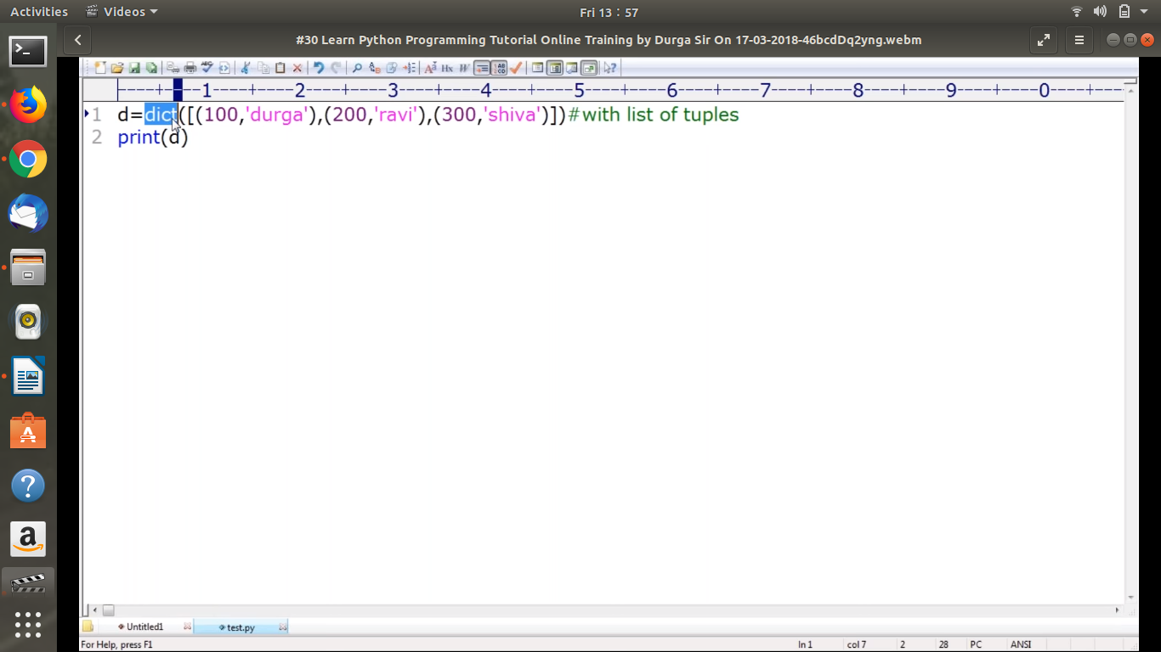
#in dict()function there can be list, tuple,set but internally it must be tuple
Internally tuple

Dictionary Comprehension:
dict = {key:value for x in sequence}
FUNTION:

In Python, function is a group of related statements that perform a specific task.
Functions help break our program into smaller and modular chunks. As our program grows larger and larger, functions make it more organized and manageable.
#group of statements
#code resueability

def funtion_name(argument):
body

In Pyton two type of functions:
1. Inbuilt function
2. User define funtion

PARAMETERS:
four type of parameters
1. positional argument:
numders of positional argument must be match
order is important

example:
def calc(a,b):
t=calc(100,50)

2. keyword argument:
numbers of argument must be match
any order can take

example:
def calc(a,b):
t=calc(a=100,b=50)
#t=calc(b=100,a=50)

#after keyword argument we cannot take positional argument

example:
SyntaxError: positional argument follows keyword argument

calc(100,b=50)
calc(b=50,100)
calc(50,a=100)

TypeError: calc() got multiple values for argument ‘a’

3. defaults
default argument should be last

SyntaxError: non-default arguments follows defaults argument
example:
def wish(name=’Guest’, msg):pass

example:

def wish(msg,name=’Guest’):pass

4. variable length arguments:
use to passing any number of argument to single parameter.

Star means any number of argument will be accepted

example:
def sum(*n):

sum()
sum(10)

Here ‘n’ means tuple.
‘n’ return tuple
sum(10,20)
sum(10,20,30)
sum(10,20,30,40)

example: WAP to print sum of given n numbers

def sum(*n):
result = 0
for x in n:
result = result+x
print('The sum: ',result)

sum()
sum(10)
sum(10,20)
sum(10,20,30)
sum(10,20,30,40)

RULE: Keyword argument follow by var argument then we have to pass positional argument
example: var agrument with positional argu

def sum(name,*n):
result = 0
for x in n:
result = result+x
print('The sum by',name,': ',result)

sum('ayush')
sum('pushpa',10)
sum('gunjan',10,20)
sum('prerna',10,20,30)
sum('pulkit',10,20,30,40)

example: var srgument with keyword argument
RULE:After variable length argument, if u r taking any other argument then we have to provide values as keyword arguments only.
def sum(*n,name):
result = 0
for x in n:
result = result+x
print('The sum by',name,': ',result)

sum(name='ayush')
sum(10,name='pushpa')
sum(10,20,name='gunjan')
sum(10,20,30,name='prerna')
sum(10,20,30,40,name='pulkit')

5. keyword vairiable lenth argument:
def disp(**n:)

example: 22:
def display(**kwargs):
print('Record Informtion')
for k,v in kwargs.items():
print(k,'.....',v)

display(name='werwre',marks=100,age=46,GF='sfsew')
display(name='ravi',wife1='sfsf',wife2='dfsd',wife='fesf')

RETURN:
any numbers of value can return

example:
def calc(a,b):
sum = a+b
sub = a-b
mul = a*b
Return value can be tuple
div = a/b
return sum,sub,mul,div

t = calc(100,50)
#a,b,c,d = calc(100,50)

VARIABLE:
1. Global varible:

2. Local variable:

RECURSIVE FUNCTIONS:
A function that calls itself recursive functions

example: 23
factorial(n)=n*factorial(n-1)

Advantages of recursive function:
reduce the length of the code and improves readability
very complex problem we can solve easily: towers of hanoi

ANONYMOUS FUNCTIONS:
without name
nameless functions
use of anaymous funtions is instant use(only one time usage)

syntax of lambda:
lambda input:expression

example: to print square of n using lambda function
s = lambda n:n*n
print(s(4))

example: to print sum of two number using lambda function
s = lambda a,b:a+b
print(‘The sum of {} and {} is:{}’.format(2,4,s(2,4)))
print(‘The sum of {} and {} is:{}’.format(20,40,s(20,40)))

example:
s = lambda a,b: a if a>b else b
print(‘The biggest of {} and {} is:{}’,.format(10,20,s(10,20)))

we can pass a function as argument to another funtion
by using lambda functon and
filter()
Always required another function as argument.

map()
reduce()

1. filter():
syntax:
filter(function,sequence)

If value is True then concider

If valueis Fales then ignore

example:
def iseven(x):
if x%2==0:
return True
else:
return False
l=[0,5,10,15,20,25,30]
l1=list(filter(iseven,l1))
print(l1) #[0,10,20,30]

2. map():
syntax: map(funtion,sequence)

example:
def double(x):
return 2*x
l=[1,2,3,4,5]
l1=list(map(double,l))
print(l1) #[1,4,6,8,10]

3. reduce():

NESTED FUNCTIONS:
to define function specific repeatedly required functionality

example:24
def f1():
def inner(a,b):
print('The sum:',a+b)
print('The average:',(a+b)/2)
print()
inner(10,20)
inner(20,30)
inner(40,50)

f1()

a function can return another function(inner function directliy calling from outside)

example:25
def outer():
print('outer function started')
def inner():
print('inner function execution')
print('outer function returning inner function')
return inner #this is returning inner function
#return inner() #this is returning inner value

f1=outer()
f1() #inner function directly cslling from outside

FUNCTION ALIASING:

example:
#f1=outer() #function call

f1=outer ==> for outer function we are giving another name is called aliasing

FUNCTION DECORATORS:

input function ==> decorator function ==> output with extended functionality
example: Bride ==> beautipalur ==> Heroine
#without modifing existing function, if you want to generate extended function ==> #new function has extended functionality
decoraters help to make our code shorter and more pyhonic
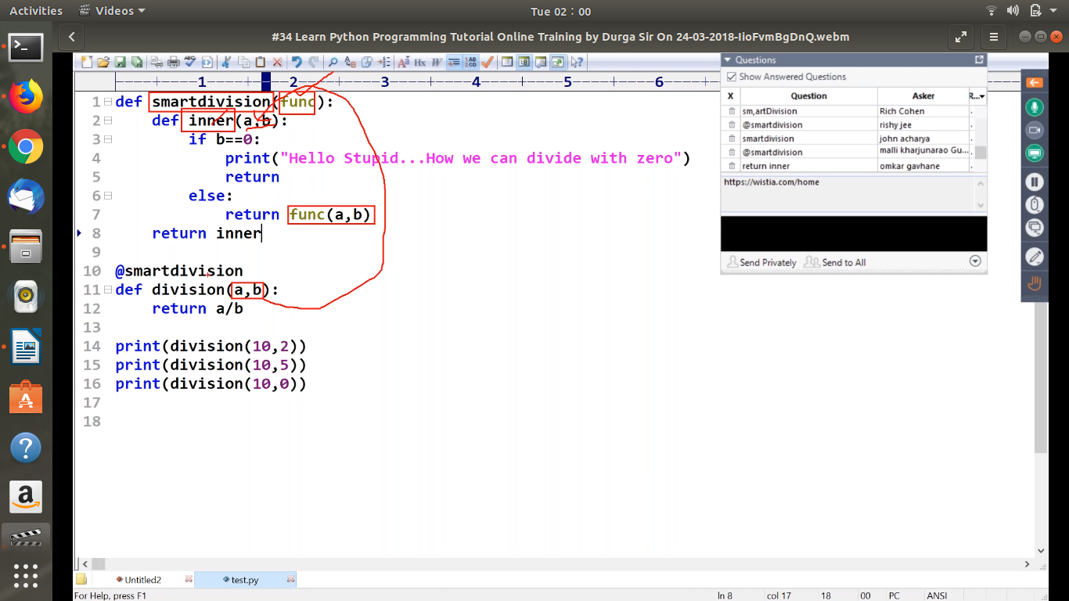

Argument name should be same

MODULES:

a group of functions and variable save in file
code reusability
length of the code will reduced and readability
maintaiability

import module1
import moudle1,module2,module3
import module1 as m1

PYC ==> __pycache__

RELOADING A MODULE:

modules is load only once
so use updated version of modle then reload() function
from imp import reload
relaod(module_name)

example:
create module1.py:
print(‘This is first version’)

create tet.py
import time
from imp imort reload
import module1
print(‘program entering into sleep state’)
time.sleep(30)
reload(module1)
print(‘this is last line of program’)

python test.py

Now modify the module1.py
print(‘this is second vrsion’)

output:

This is first version
program entering into sleep state
this is second vrsion
this is last line of program
-----------------

finding members of a module by using dir() function:

dir() ==> list of current module members
dir(module_name)

THE SPECIAL VARIABLE __name__:

Ques: in my program, module is executed 1) directly like another program or
2) just like a module in anotherprogram indirectly

Ans:
1) if it is executed directly then variable __name__ == __main__
2) if it is executed indirectly then variable __name__ == module_name
example:module1.py and test.py

Create module1.py
def f1():
if __name__=='__main__':
print('The code execued directly as a program')
print('The value of __name__:',__name__)
else:
print('The code executed indirectly as a modulefrom some other program')
print('The value of __name__:',__name__)

f1()

ayushsahu@sysadmin:~/Programs$ python3 module1.py
The code execued directly as a program
The value of __name__: __main__

Create test.py
import module1
print('from test we are executing module1 f1()')
module1.f1()

ayushsahu@sysadmin:~/Programs$ python3 test.py
The code executed indirectly as a modulefrom some other program
The value of __name__: module1
from test we are executing module1 f1()
The code executed indirectly as a modulefrom some other program
The value of __name__: module1

help(module_name)

WORKING WITH RANDOM MODULE:

to generate random numbers

1. random() function:
between 0 and 1 (not inclusive)

example: prog27.py
from random import *
for i in range(10):
print(random())

2. randint() function:
example: randint(1,100) (inclusive)

example:
from random import *
for i in range(20):
print(randint(1,100))

3. uniform() funtion:
generate float value in given range (not inclusive)

4. randrange(start,stop,step)
start(inclusive) <= x < stop(not iclusive)
default start value is zero
default step value is 1

example:
from random import *
for i in range(20):
print(randrange(1,10))

5. choice() function:
it don’t return random nummber
it return random object from the collection

from random import *
list = (‘ayush’,’raj’,’prerna’,’pulkit’)
for i in range(20):
print(choice(list))
MODULES
EXCEPTION HANDLING
FILE HANDLING
ASSERTION
PYTHON DATABASE CONNECTIVITY
REGULAR EXPRESSIONS
MULTI THREADING
GENERATORS

VARIOUS POSSIBLE COMBINATION OF TRY-EXCEPT-ELSEE-FINALLY BLOCKS:

1. try block compulsory we should write either except or finally block
2. except without try is invalid
3. finally without try is invalid
4. we can take multiple except blocks for the same try but we can’t take multiple except and finally
5. else without except is invalid
6. try-excet-elsee-finally order is important
7. we can take try-except-else-finally in try,except,else,finally blocks. Nesting of try-except-else-finally is possible.

TYPES OF EXCEPTIONS:

1. Predefined exceptions/Inbuilt exceptions
2. User defined exceptions/Customized exception

------------------------------------

OOP’s:

class
object
reference variable

class is template/blue print
the physical existence of class is nothing but object

class object ==> one to many
object reference variable ==> one to one or one to many

DOC STRING:

example:
class Student:
‘’’This class developrd by Ayush for demo’’’

print(Student.__doc__) # This class developrd by Ayush for demo

SELF VARIABLE:

Self is a reference variable which is always pointing to current object.
Within the python cass to refer current object we chould use self variable.
The first agument to the constructor and instance method should be self.
PVM is responsible to provide value for self argument andwe are not requied to provide explicitly.
By using self we can declare instance variables.
By using self we can access instance variables.
Instead of selfwe can use any name, but recommended to use self.

Example:
class Student:
‘’’This class developrd by Ayush for demo’’’
def __init__(self):
print(id(self)) #32281112

s=Student()
print(id(s)) #32281112

#outside of the class how can access the object==> by using explicit reference variable
#inside of the class how can access the object ==> by using self reference variable.

CONSTRUCTOR:
The name should be always: __init__()
Whenerver we are creating object constructor will be executed automatically and we are not required to call explicitly.
The main objective of constructor is to declred and initialize variable.
For every object constructor will be executed only once.
Every constructor should take atleast one argument that is self.
If you are not writing constructor then Python will provide default constructor.

THREE TYPE OF VARIABLES:
1. Instance Variables/Object Level Variable
2. Static Variables/Class Level Variable
3. Local variables/Method Variable
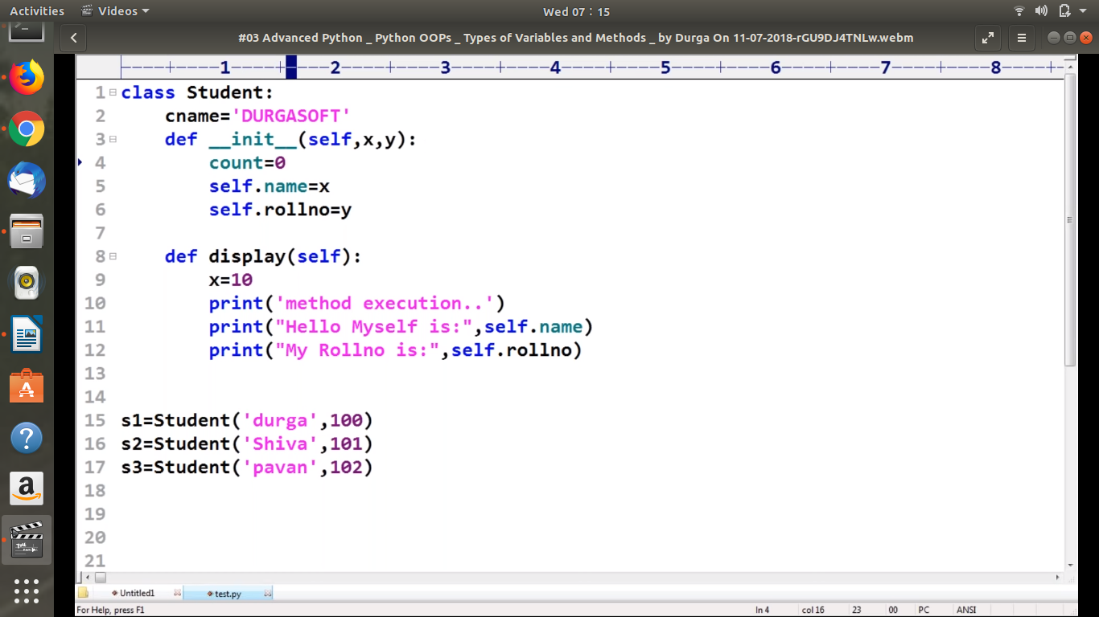

THREE TYPE OF METHODS:
1. Instance Methods/Objecr Related Methods
2. Static Methods
3. Local Methods
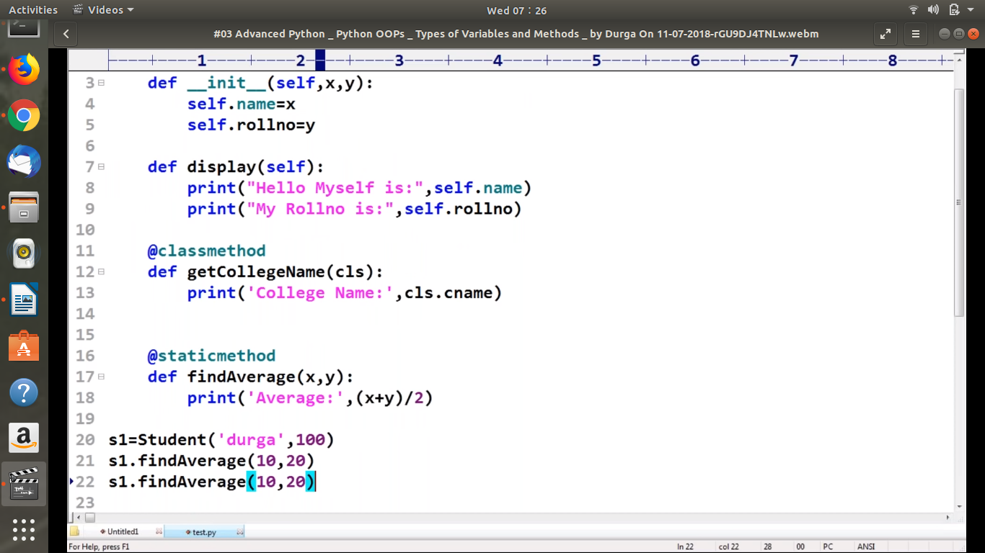

Note: The __init__() function is called automatically every time the class is being used to create a new object.

Note: The self parameter is a reference to the current instance of the class, and is used to access variables that belong to the class.

The self Parameter
The self parameter is a reference to the current instance of the class, and is used to access variables that belongs to the class.
It does not have to be named self , you can call it whatever you like, but it has to be the first parameter of any function in the class:

ASCII Chart
Decimal | Binary | Octal | Hexadecimal | Symbol | Description
0 | 0 | 0 | 0 | NUL | Null char
1 | 1 | 1 | 1 | SOH | Start of Heading
2 | 10 | 2 | 2 | STX | Start of Text
3 | 11 | 3 | 3 | ETX | End of Text
4 | 100 | 4 | 4 | EOT | End of Transmission
5 | 101 | 5 | 5 | ENQ | Enquiry
6 | 110 | 6 | 6 | ACK | Acknowledgement
7 | 111 | 7 | 7 | BEL | Bell
8 | 1000 | 10 | 8 | BS | Back Space
9 | 1001 | 11 | 9 | HT | Horizontal Tab
10 | 1010 | 12 | 0A | LF | Line Feed
11 | 1011 | 13 | 0B | VT | Vertical Tab
12 | 1100 | 14 | 0C | FF | Form Feed
13 | 1101 | 15 | 0D | CR | Carriage Return
14 | 1110 | 16 | 0E | SO | Shift Out / X-On
15 | 1111 | 17 | 0F | SI | Shift In / X-Off
16 | 10000 | 20 | 10 | DLE | Data Line Escape
17 | 10001 | 21 | 11 | DC1 | Device Control 1 (oft.XON)
18 | 10010 | 22 | 12 | DC2 | Device Control 2
19 | 10011 | 23 | 13 | DC3 | Device Control 3 (oft.XOFF)
20 | 10100 | 24 | 14 | DC4 | Device Control 4
21 | 10101 | 25 | 15 | NAK | Negative Acknowledgement
22 | 10110 | 26 | 16 | SYN | Synchronous Idle
23 | 10111 | 27 | 17 | ETB | End of Transmit Block
24 | 11000 | 30 | 18 | CAN | Cancel
25 | 11001 | 31 | 19 | EM | End of Medium
26 | 11010 | 32 | 1A | SUB | Substitute
27 | 11011 | 33 | 1B | ESC | Escape
28 | 11100 | 34 | 1C | FS | File Separator
29 | 11101 | 35 | 1D | GS | Group Separator
30 | 11110 | 36 | 1E | RS | Record Separator
31 | 11111 | 37 | 1F | US | Unit Separator
32 | 100000 | 40 | 20 | SPACE | Space
33 | 100001 | 41 | 21 | ! | Exclamation mark
34 | 100010 | 42 | 22 | “ | Double quotes (or speech marks)
35 | 100011 | 43 | 23 | # | Number
36 | 100100 | 44 | 24 | $ | Dollar
37 | 100101 | 45 | 25 | % | Percent
38 | 100110 | 46 | 26 | & | Ampersand
39 | 100111 | 47 | 27 | ‘ | Single quote
40 | 101000 | 50 | 28 | ( | Open parenthesis (or open bracket)
41 | 101001 | 51 | 29 | ) | Close parenthesis (orclose bracket)
42 | 101010 | 52 | 2A | * | Asterisk
43 | 101011 | 53 | 2B | + | Plus
44 | 101100 | 54 | 2C | , | Comma
45 | 101101 | 55 | 2D | - | Hyphen
46 | 101110 | 56 | 2E | . | Period, dot or full stop
47 | 101111 | 57 | 2F | / | Slash or divide
48 | 110000 | 60 | 30 | 0 | Zero
49 | 110001 | 61 | 31 | 1 | One
50 | 110010 | 62 | 32 | 2 | Two
51 | 110011 | 63 | 33 | 3 | Three
52 | 110100 | 64 | 34 | 4 | Four
53 | 110101 | 65 | 35 | 5 | Five
54 | 110110 | 66 | 36 | 6 | Six
55 | 110111 | 67 | 37 | 7 | Seven
56 | 111000 | 70 | 38 | 8 | Eight
57 | 111001 | 71 | 39 | 9 | Nine
58 | 111010 | 72 | 3A | : | Colon
59 | 111011 | 73 | 3B | ; | Semicolon
60 | 111100 | 74 | 3C | < | Less than (or open angled bracket)
61 | 111101 | 75 | 3D | = | Equals
62 | 111110 | 76 | 3E | > | Greater than (or closeangled bracket)
63 | 111111 | 77 | 3F | ? | Question mark
64 | 1000000 | 100 | 40 | @ | At symbol
65 | 1000001 | 101 | 41 | A | Uppercase A
66 | 1000010 | 102 | 42 | B | Uppercase B
67 | 1000011 | 103 | 43 | C | Uppercase C
68 | 1000100 | 104 | 44 | D | Uppercase D
69 | 1000101 | 105 | 45 | E | Uppercase E
70 | 1000110 | 106 | 46 | F | Uppercase F
71 | 1000111 | 107 | 47 | G | Uppercase G
72 | 1001000 | 110 | 48 | H | Uppercase H
73 | 1001001 | 111 | 49 | I | Uppercase I
74 | 1001010 | 112 | 4A | J | Uppercase J
75 | 1001011 | 113 | 4B | K | Uppercase K
76 | 1001100 | 114 | 4C | L | Uppercase L
77 | 1001101 | 115 | 4D | M | Uppercase M
78 | 1001110 | 116 | 4E | N | Uppercase N
79 | 1001111 | 117 | 4F | O | Uppercase O
80 | 1010000 | 120 | 50 | P | Uppercase P
81 | 1010001 | 121 | 51 | Q | Uppercase Q
82 | 1010010 | 122 | 52 | R | Uppercase R
83 | 1010011 | 123 | 53 | S | Uppercase S
84 | 1010100 | 124 | 54 | T | Uppercase T
85 | 1010101 | 125 | 55 | U | Uppercase U
86 | 1010110 | 126 | 56 | V | Uppercase V
87 | 1010111 | 127 | 57 | W | Uppercase W
88 | 1011000 | 130 | 58 | X | Uppercase X
89 | 1011001 | 131 | 59 | Y | Uppercase Y
90 | 1011010 | 132 | 5A | Z | Uppercase Z
91 | 1011011 | 133 | 5B | [ | Opening bracket
92 | 1011100 | 134 | 5C | \ | Backslash
93 | 1011101 | 135 | 5D | ] | Closing bracket
94 | 1011110 | 136 | 5E | ^ | Caret - circumflex
95 | 1011111 | 137 | 5F | _ | Underscore
96 | 1100000 | 140 | 60 | ` | Grave accent
97 | 1100001 | 141 | 61 | a | Lowercase a
98 | 1100010 | 142 | 62 | b | Lowercase b
99 | 1100011 | 143 | 63 | c | Lowercase c
100 | 1100100 | 144 | 64 | d | Lowercase d
101 | 1100101 | 145 | 65 | e | Lowercase e
102 | 1100110 | 146 | 66 | f | Lowercase f
103 | 1100111 | 147 | 67 | g | Lowercase g
104 | 1101000 | 150 | 68 | h | Lowercase h
105 | 1101001 | 151 | 69 | i | Lowercase i
106 | 1101010 | 152 | 6A | j | Lowercase j
107 | 1101011 | 153 | 6B | k | Lowercase k
108 | 1101100 | 154 | 6C | l | Lowercase l
109 | 1101101 | 155 | 6D | m | Lowercase m
110 | 1101110 | 156 | 6E | n | Lowercase n
111 | 1101111 | 157 | 6F | o | Lowercase o
112 | 1110000 | 160 | 70 | p | Lowercase p
113 | 1110001 | 161 | 71 | q | Lowercase q
114 | 1110010 | 162 | 72 | r | Lowercase r
115 | 1110011 | 163 | 73 | s | Lowercase s
116 | 1110100 | 164 | 74 | t | Lowercase t
117 | 1110101 | 165 | 75 | u | Lowercase u
118 | 1110110 | 166 | 76 | v | Lowercase v
119 | 1110111 | 167 | 77 | w | Lowercase w
120 | 1111000 | 170 | 78 | x | Lowercase x
121 | 1111001 | 171 | 79 | y | Lowercase y
122 | 1111010 | 172 | 7A | z | Lowercase z
123 | 1111011 | 173 | 7B | { | Opening brace
124 | 1111100 | 174 | 7C | | | Vertical bar
125 | 1111101 | 175 | 7D | } | Closing brace
126 | 1111110 | 176 | 7E | ~ | Equivalency sign - tilde
127 | 1111111 | 177 | 7F | DEL | Delete

